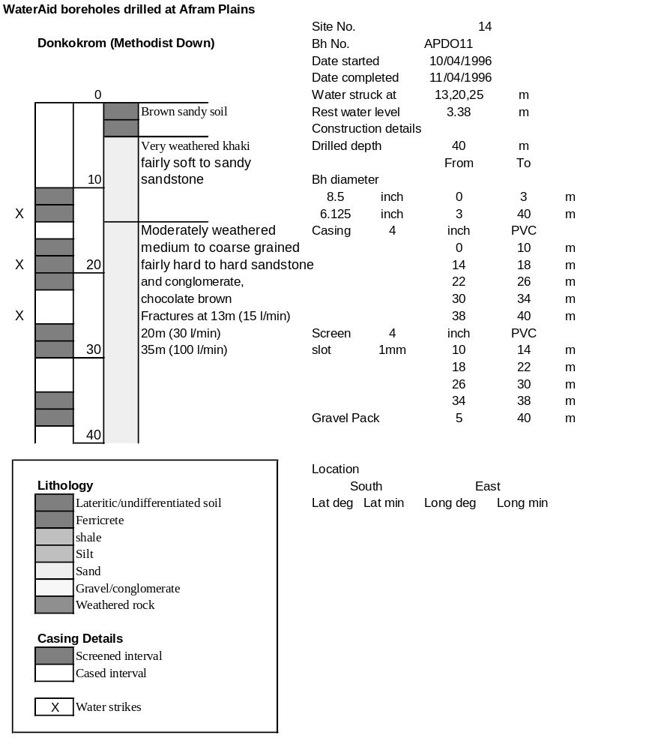

Ghana | Test pumping
Borehole No. |  | APDO11
Hole No |  | 14
Village |  | Donkokrum Methodist
Date |  | 19/04/1996
Point above GL |  | 0.5 | m
Pump depth |  | 24 | m
SWL |  | 3.88 | m
Start Time |  | 14:15
Drawdown test |  |  |  |  | Recovery test
time | pwl (m) | Q l/min | dd | sc | Time | wl (m) | s' | t/t'
0.00 | 3.88 | 120.00 | 0.00 |  | 0.00 | 6.84 | 2.96
1.00 | 5.78 | 120.00 | 1.90 | 63.16 | 1.00 | 4.65 | 0.77 | 181.00
2.00 | 5.91 | 120.00 | 2.03 | 59.11 | 2.00 | 4.60 | 0.72 | 91.00
3.00 | 6.01 | 120.00 | 2.13 | 56.34 | 3.00 | 4.56 | 0.68 | 61.00
4.00 | 6.07 | 120.00 | 2.19 | 54.79 | 4.00 | 4.54 | 0.66 | 46.00
5.00 | 6.10 | 120.00 | 2.22 | 54.05 | 5.00 | 4.52 | 0.64 | 37.00
6.00 | 6.13 | 120.00 | 2.25 | 53.33 | 6.00 | 4.50 | 0.62 | 31.00
7.00 | 6.16 | 120.00 | 2.28 | 52.63 | 7.00 | 4.48 | 0.60 | 26.71
8.00 | 6.19 | 120.00 | 2.31 | 51.95 | 8.00 | 4.47 | 0.59 | 23.50
9.00 | 6.22 | 120.00 | 2.34 | 51.28 | 9.00 | 4.46 | 0.58 | 21.00
10.00 | 6.25 | 120.00 | 2.37 | 50.63 | 10.00 | 4.45 | 0.57 | 19.00
11.00 | 6.27 | 120.00 | 2.39 | 50.21 | 12.00 | 4.43 | 0.55 | 16.00
12.00 | 6.28 | 120.00 | 2.40 | 50.00 | 14.00 | 4.41 | 0.53 | 13.86
13.00 | 6.29 | 120.00 | 2.41 | 49.79 | 16.00 | 4.39 | 0.51 | 12.25
14.00 | 6.30 | 120.00 | 2.42 | 49.59 | 18.00 | 4.38 | 0.50 | 11.00
15.00 | 6.31 | 120.00 | 2.43 | 49.38 | 20.00 | 4.36 | 0.48 | 10.00
16.00 | 6.32 | 120.00 | 2.44 | 49.18 | 22.00 | 4.35 | 0.47 | 9.18
17.00 | 6.35 | 120.00 | 2.47 | 48.58 | 24.00 | 4.34 | 0.46 | 8.50
18.00 | 6.36 | 120.00 | 2.48 | 48.39 | 26.00 | 4.33 | 0.45 | 7.92
19.00 | 6.37 | 120.00 | 2.49 | 48.19 | 28.00 | 4.32 | 0.44 | 7.43
20.00 | 6.36 | 120.00 | 2.48 | 48.39 | 30.00 | 4.31 | 0.43 | 7.00
22.00 | 6.37 | 120.00 | 2.49 | 48.19 | 35.00 | 4.29 | 0.41 | 6.14
24.00 | 6.38 | 120.00 | 2.50 | 48.00 | 40.00 | 4.28 | 0.40 | 5.50
26.00 | 6.42 | 120.00 | 2.54 | 47.24 | 45.00 | 4.26 | 0.38 | 5.00
28.00 | 6.41 | 120.00 | 2.53 | 47.43 | 50.00 | 4.25 | 0.37 | 4.60
30.00 | 6.41 | 120.00 | 2.53 | 47.43 | 60.00 | 4.23 | 0.35 | 4.00
35.00 | 6.48 | 120.00 | 2.60 | 46.15 | 70.00 | 4.21 | 0.33 | 3.57
40.00 | 6.48 | 120.00 | 2.60 | 46.15 | 80.00 | 4.19 | 0.31 | 3.25
45.00 | 6.51 | 120.00 | 2.63 | 45.63 | 90.00 | 4.18 | 0.30 | 3.00
50.00 | 6.52 | 120.00 | 2.64 | 45.45 | 100.00 | 4.17 | 0.29 | 2.80
55.00 | 6.56 | 120.00 | 2.68 | 44.78 | 110.00 | 4.16 | 0.28 | 2.64
60.00 | 6.55 | 120.00 | 2.67 | 44.94 | 120.00 | 4.15 | 0.27 | 2.50
70.00 | 6.58 | 120.00 | 2.70 | 44.44
80.00 | 6.60 | 120.00 | 2.72 | 44.12
90.00 | 6.64 | 120.00 | 2.76 | 43.48
100.00 | 6.67 | 120.00 | 2.79 | 43.01
110.00 | 6.69 | 120.00 | 2.81 | 42.70
120.00 | 6.73 | 120.00 | 2.85 | 42.11
130.00 | 6.75 | 120.00 | 2.87 | 41.81
140.00 | 6.77 | 120.00 | 2.89 | 41.52
160.00 | 6.80 | 120.00 | 2.92 | 41.10
180.00 | 6.84 | 120.00 | 2.96 | 40.54
